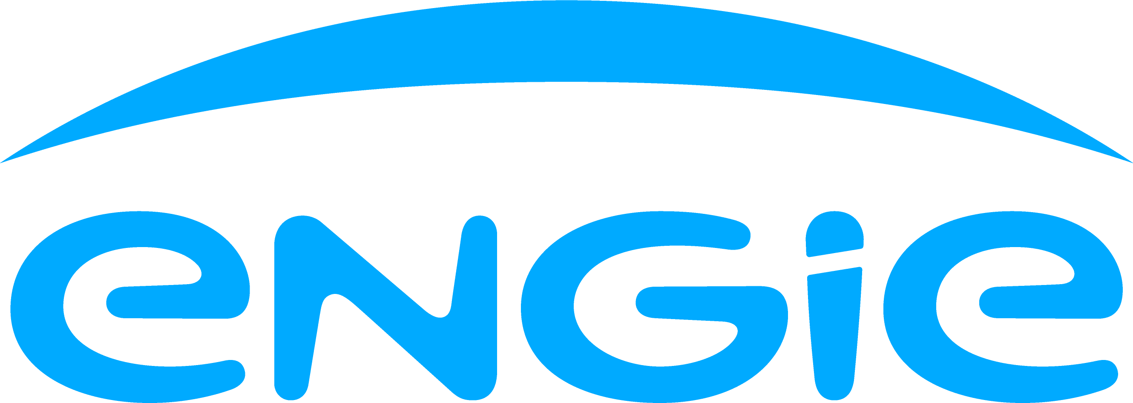

FIRST HYDRO COMPANY
REQUEST FOR SPONSORSHIP - APPLICATION FORM

Please read the enclosed Guidance Document carefully before completing this form.
If you require any assistance or the form in a different format,
please contact Claire Branston at First Hydro Company - details at the end of the form.

QUESTION 1

Name of Club/Group/Society
(this name should also be your bank account name)
Contact Name
Your Position in Club/Group/Society
Address
Post Code
Daytime Telephone Number 
Mobile Number
E-mail

QUESTION 2

What kind of group/society  are you? | Tick one box only |  | 
What kind of group/society  are you? | Community Group/Voluntary with a Constitution
What kind of group/society  are you? | Registered Charity
What kind of group/society  are you? | Local Branch of a National Organisation
What kind of group/society  are you? | Company Limited by Guarantee
What kind of group/society  are you? | Other
Do you work for FHC?
Is there a link to FHC? If so, please describe/please name the FHC person
Charity number or other registered number
(if applicable)
When was the group established? | Year | Month
How many people does your group employ? (If any)
How many people does your group benefit?

QUESTION 3

Please explain briefly what is the main activity of your group and what you will do with the funding, if successful.

QUESTION 4
Which communities and specific people will benefit from the scheme?

QUESTION 5

How will the scheme meet the aims and objectives of the First Hydro Company Policy?

QUESTION 6

How many individuals and groups will gain directly from this development?
Number
Individuals _______

Groups _______

QUESTION 7

Explain briefly how you will manage the project i.e. responsibility for staff and/or volunteers?

QUESTION 8

What is the total amount of funding that you are applying for? | £
Will this be the total cost of the scheme? | Yes No
What will be the groups’ contribution to the project costs? | £
Please list below the details of all items of expenditure you’re applying for

Item of expenditure |  | Cost | Total
Please include quotes
Total |  | £ | £
Please list below details of any Match Funding secured or you’ve applied for towards your project
Funding source/body |  | Sum | Total
Total |  | £ | £

QUESTION 9

Have you previously received funding from First Hydro Company? Yes/No
If Yes, please give details and how this has benefitted your organisation.

QUESTION 10

What steps will you take to ensure the continuation of the project after funding from
First Hydro Company has been used?

QUESTION 11

I affirm on behalf of my group/society that I have the authority to sign this statement; that to the best of my ability the information on this form is true and correct.

I understand that the money has to be spent according to the conditions that it was offered to us and if this is not possible that the money will have to be partly
or completely repaid.

Main contact
Name
Signature
Date
Other member of the committee:
Name
Signature
Date
At least one signatory has to be an officer on the Management Committee

When you’ve completed each part of the application form and attached all relevant documents, please return to:

fhc.sponsanddons@engie.com

